**Department of Computing**

**CS-213: Advanced Programming**

**Class: BSCS 7AB**

**Lab 08: React JS**

**Date: 07 November, 2019**

**Time: 10:00-01:00pm & 02:00-05:00pm**

**Submitted By : Muhammad Nouman Imran (215192)**

**Instructor: Dr. Sidra Sultana**

**Lab Engineer: Ms. Ayesha Asif**

**Lab 08: ReactJS States**

**Introduction**

This lab is about the states of the ReactJS library, creating a timer using ReactJS states.

**Objectives**

This lab will get students familiar with the ReactJS states and creating a timer application.

**Tools/Software Requirement**

Notepad/Notepad++, Node.js, ReactJS

**Helping Material:**

Class lectures

ReactJS tuturials:

<https://www.javatpoint.com/reactjs-tutorial>

**Lab Tasks**

1. You have to practice the states codes covered in class lecture

**Code:**

**import React from 'react';**

**import logo from './logo.svg';**

**import './App.css';**

**class App extends React.Component {**

**constructor(props) {**

**super(props);**

**this.state = {**

**brand: "Ford",**

**model: " Mustang ",**

**color: "red",**

**year: 1964**

**};**

**}**

**changeColor = () => {**

**this.setState({color: "blue"});**

**}**

**render() {**

**return (**

**<div>**

**<h1>My {this.state.brand}</h1>**

**<p>**

**It is a {this.state.color}**

**{this.state.model}**

**from {this.state.year}.**

**</p>**

**<button**

**type="button"**

**onClick={this.changeColor}**

**>Change color</button>**

**</div>**

**);**

**}**

**}**

**export default App;**

**Output:**

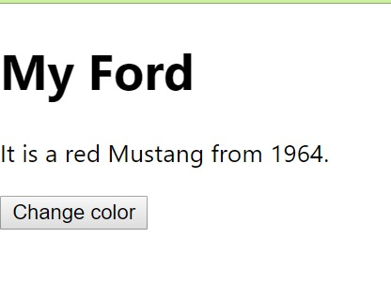

1. Create a timer application which asks the user for minutes. The user then click Start button and starts the timer count down. Preview @ <https://7zyz2y4p5j.csb.app/>

**Code:**

**import React from "react";**

**import ReactDOM from "react-dom";**

**class TimerInput extends React.Component {**

**render() {**

**return (**

**<div style={{marginLeft:100}}>**

**<h3>Input your desired time</h3>**

**<input type="number" value={this.props.value} onChange={this.props.handleChange} required />**

**</div>**

**);**

**}**

**}**

**class Timer extends React.Component {**

**render() {**

**return (**

**<div>**

**<h1 style={{ fontSize: 100, marginLeft:100 }}>{this.props.value}:{this.props.seconds}</h1>**

**</div>**

**);**

**}**

**}**

**class StartButton extends React.Component {**

**render() {**

**return (**

**<div style={{ marginLeft: 130 }}>**

**<button className="btn btn-lg btn-success" disabled={!this.props.value} onClick={this.props.startCountDown}>Start</button>**

**</div>**

**);**

**}**

**}**

**class App extends React.Component {**

**constructor(props) {**

**super(props);**

**this.state = {**

**seconds: '00',**

**value: '',**

**isClicked : false**

**}**

**this.handleChange = this.handleChange.bind(this);**

**this.startCountDown = this.startCountDown.bind(this);**

**this.tick = this.tick.bind(this);**

**}**

**handleChange(event) {**

**this.setState({**

**value: event.target.value**

**})**

**}**

**tick() {**

**var min = Math.floor(this.secondsRemaining / 60);**

**var sec = this.secondsRemaining - (min * 60);**

**this.setState({**

**value: min,**

**seconds: sec,**

**})**

**if (sec < 10) {**

**this.setState({**

**seconds: "0" + this.state.seconds,**

**})**

**}**

**if (min < 10) {**

**this.setState({**

**value: "0" + min,**

**})**

**}**

**if (min === 0 & sec === 0) {**

**clearInterval(this.intervalHandle);**

**}**

**this.secondsRemaining--**

**}**

**startCountDown() {**

**this.intervalHandle = setInterval(this.tick, 1000);**

**let time = this.state.value;**

**this.secondsRemaining = time * 60;**

**this.setState({**

**isClicked : true**

**})**

**}**

**render() {**

**const clicked = this.state.isClicked;**

**if(clicked){**

**return (**

**<div>**

**<div className="row">**

**<div className="col-md-4"></div>**

**<div className="col-md-4">**

**<Timer value={this.state.value} seconds={this.state.seconds} />**

**</div>**

**</div>**

**</div>**

**);**

**}else{**

**return (**

**<div>**

**<div className="row">**

**<div className="col-md-4"></div>**

**<div className="col-md-4">**

**<TimerInput value={this.state.value} handleChange={this.handleChange} />**

**<Timer value={this.state.value} seconds={this.state.seconds} />**

**<StartButton startCountDown={this.startCountDown} value={this.state.value} />**

**<br/>**

**<br/>**

**</div>**

**</div>**

**</div>**

**);**

**}**

**}**

**}**

**const rootElement = document.getElementById("root");**

**ReactDOM.render(<App />, rootElement);**

**Output:**

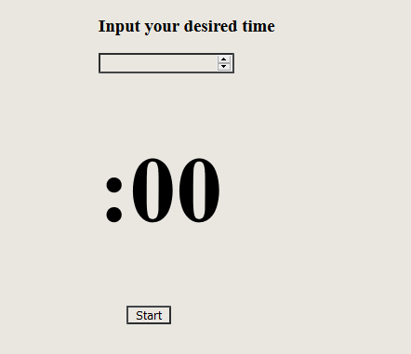

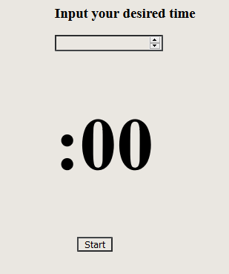

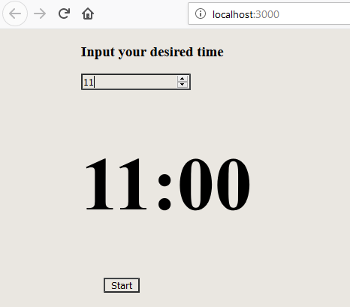

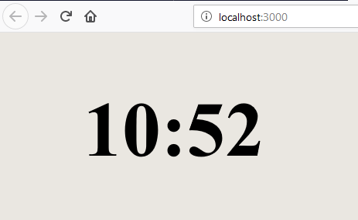

**Deliverables**

Compile the Lab Submission File (Uploaded on LMS) by filling in the solution part with your source code and screenshots and submit it on LMS. The lab grading policy is as follows:

The lab is graded between 0 to 10 marks. At the end of each lab or in the next lab, there will be a viva related to the tasks. The viva has a weightage of 5 marks. Insert the solution/answer in this document. You must show the implementation of the tasks in the designing tool, along with your complete Word document to get maximum grade. In case of any problems with submissions on LMS, Email to Mr. Ahsan Gul: [ahsan.gul@seecs.edu.pk](mailto:ahsan.gul@seecs.edu.pk)